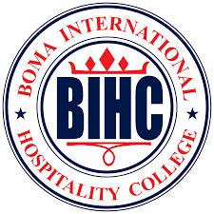
THE ROLE OF FRONT OFFICE DEPARTMENT TOWARDS GUEST SATISFACTION IN FIVE STAR IN NAIROBI :A LOOK AT KWETU CURIO COLLECTION BY HILTON NAIROBI.

MARTHA MKANYIKA M’MBOLOLO
ADMISSION NUMBER:23081005

RESEARCH PROPOSAL SUBMITTED IN PARTIAL FULFILMENT OF THE REQUIREMENT FOR THE AWARD OF A DIPLOMA IN CULINARY ARTS, BOMA INTERNATIONAL HOSPITALITY COLLEGE.
OCTOBER,2024

DECLARATION
Student’s Declaration
“I declare this proposal is my original work and has not been presented for a diploma in any other institution.”
Name: Martha Mkanyika M’mbololo
Adm No: 23081005
Signature:
Date:

Supervisor’s Declaration
“This proposal has been submitted for appraisal with my approval as college supervisor”.
Name: Naomy Mwaurah
Department: Library
College: Boma International Institute
Signature:
Date:

DEDICATION
I would like to dedicate this work to the Lord for giving me another opportunity to pursue what I am passionate about and also to my family for giving me love and support throughout this journey.

ACKNOWLEDGEMENT
I am grateful to Boma International Hospitality College for offering facilities and resources for this project. Their support facilitated the smooth execution of the research.
Lastly, I would like to express my sincere gratitude to my supervisor Naomy Mwaurah for guiding me through this project and my family for their immense support.

ABSTRACT
The primary goal of this study on the contribution of the front office department to client happiness at five-star hotels— Kwetu Curio Collection by Hilton—is to examine how the front office department affects customer satisfaction. The study will look into the responsibilities of front office in visitor satisfaction, the hotel guest cycle, and new trends in front office at Kwetu Curio, it will also look into the key areas for improvement. The research will use both quantitative and qualitative approaches to determine the function of the front office in guest satisfaction, with data collected through questionnaires.

The study discovered that customers had a positive impression of the front desk staff at the hotel. However, the majority of the guests did not believe that the front desk staff inspired visitors and that information about the hotel was insufficiently available. It was also shown that the level of service provided by front desk workers has a substantial impact on client satisfaction. The front desk staff lacked treatment equality, attention to detail and language proficiency. The report advises hotels to engage in highly motivated front desk staff through capacity building of front office staff on how to inspire visitors to attract more customers and training of the staff on how to be more sensitive to guest’s wants and preferences to improve the overall guest experience.

TABLE OF CONTENTS
DECLARATION 2
DEDICATION 3
ACKNOWLEDGEMENT 4
ABSTRACT 5
CHAPTER ONE 8
INTRODUCTION AND BACKGROUND TO THE STUDY 8
1.1 Introduction 8
1.2 Background of the Study 8
1.3 Statement of the Problem 11
1.4 Purpose of the Study 11
1.5 Objective of the study 11
1.6 Research Questions 11
1.7 Significance of the study 12
1.8 Limitation of the study 12
1.9 Delimitation of the study 12
CHAPTER TWO 13
LITERATURE REVIEW 13
2.1 Introduction 13
2.2 Role of front office department towards guest satisfaction 13
2.3 The hotel guest cycle 15
2.5 Conclusion 17
CHAPTER 3: RESEARCH DESIGN AND METHODOLOGY 18
3.1 Introduction 18
3.2 Research Design 18
3.3. Location of the study 18
3.4 Target Population 19
3.5 Sampling Techniques and Sample Size 20
3.6 Research Instruments 20
3.7 Data Collection Procedure 21
3.8 Data Analysis 21
3.9 Logistical and Ethical Considerations 22
• 3.9.1 Privacy 22
• 3.9.2 Confidentiality 22
• 3.9.3 Voluntariness 22
REFERENCE 23
APPENDICES 25
APPENDIX 1: BUDGET 25
APPENDIX 2: WORKPLAN 26
APPENDIX 3: QUESTIONNAIRE 27

CHAPTER ONE

INTRODUCTION AND BACKGROUND TO THE STUDY

1.1 Introduction
In this chapter we shall cover the back ground of the role of the front office department towards guest satisfaction, the problem statement, the purpose of study, research objectives, research questions, the significance of the study limitations and delimitations.

1.2 Background of the Study
During my internship at Kwetu Curio collection by Hilton in Nairobi, I managed to visit the front office staff at the hotel and realized this was the first point of contact for new visitors. Kwetu Curio Collection by Hilton Nairobi stands as a beacon of hospitality excellence in the vibrant city of Nairobi, Kenya. Even though it was established in March 1, 2024, it has since garnered a reputation for unparalleled service, luxurious accommodations, and a commitment to guest satisfaction.
The core of the front desk is coordinating smooth check-ins, skilfully responding to visitor enquiries with timely and informative answers, and promptly resolving any issues that may come up. All of these initiatives work together to make a visitor's stay more enjoyable and positive overall. The hotel's reputation is protected by the front desk, which goes beyond simple administrative duties. The capacity to promptly resolve issues and guarantee visitor delight turns into a lighthouse that not only retain current visitors but also future through testimonials. (Jackson Philips, 2024)
The hotel’s brain is the functional region of the front office, which serves as the hub for liaison and communication within the running company in addition to its functions as reception and marketing. Front desk staff members play a crucial role in enhancing a hotel’s reputation and image. (Hai‐yan & Baum, 2006)
The front office Department operational role;
Guest Registration: Completes all tasks associated with guest registration, such as check-in, room assignment, greeting and room fee.
Guest Service: Completes any task pertaining to guest services.
Guest History and Records: Compiles and preserves a guest’s history, profile, preferences and comments.
Guest Database: Creates and keeps an extensive database of updates to guest information.
Room Status: In charge of maintaining accurate room statuses, such as CI, CO, DNCO and DND.
Reservation: In order to guarantee that visitors have their rooms when they at the hotel, this section is in charge of recording and filing reservation records as well as updating them at the proper times.
Postage and Packages: This area serves to assist visitors with the mailing of letters, telegrams and packages.
Telephone: Upon request, guests can be woken up in the morning and informed about the telephone both inside and externally in this part.
Finance and Foreign Exchange: This division is associated with the accounting department, collecting money from visitors through their services and providing foreign exchange services.
Question: The purpose of this part is to respond to guests’ queries. Consequently, this component would need to be aware of all.
Bell and Desk Concierge: Provides all services associated with the concierge and bell desk.(Augustine, 2024)

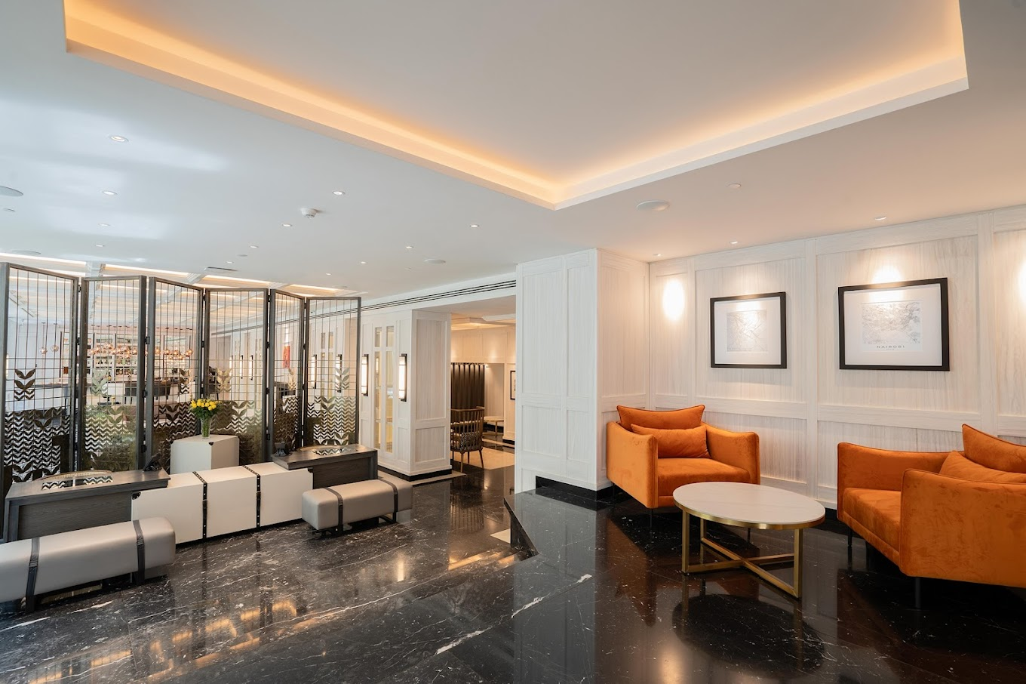

A view of the front office department at Kwetu Curio Collection by Hilton Nairobi.(Kwetu Nairobi Curio Collection by Hilton Photos - Google Search, n.d.)

1.3 Statement of the Problem
The experiences and general contentment of customers are greatly influenced by the hotel front desk. First impressions and enduring memories are created at the front desk, which serves as the main point of contact. The front desk has a startling 20–40% impact on overall client satisfaction, according to recent study, which emphasises the necessity for hotels to give this area of their operation’s top priority. Hoteliers can maintain their front desk operation as a valuable asset in the cutthroat hospitality sector by comprehending and resolving these variables, which will ultimately increase visitor happiness and loyalty. (Haenraets, 2024)

1.4 Purpose of the Study
The purpose of the study is to emphasize on the role of the front office department towards guest satisfaction, to establish the hotel guest cycle and also to focus on the emerging trends in front office.

1.5 Objective of the study
1.To identify the role of the front office department towards guest satisfaction.
2.To establish the hotel guest cycle.
3.To find out the emerging trends in front office.

1.6 Research Questions
1.What is the role of the front office towards guest satisfaction?
2.What entails the hotel guest cycle?
3.What are the emerging trends in front office department?

1.7 Significance of the study
The study will enable us to understand the current Front Office practices and the related guest satisfaction, an important component for hotels. The study will help those aspiring to join the hotel industry to understand the kinds of practices existing in the Hotel front office, the guest expectations and their preferences.

1.8 Limitation of the study
1. The current study cannot claim to be wholly conclusive as it is limited to a small sample size from only one hotel.
2.Some questions maybe left an answered and the researcher will have no control over what the respondent will answer.

1.9 Delimitation of the study
The study will focus on the hotel industry in Nairobi, Kenya and will not focus on the same impact on other cities within Kenya i.e. Mombasa and Kisumu. The research will also limit the sample size to one selected hotel in Nairobi, Kenya and may not provide an accurate representation of the entire hotel industry in the country.

CHAPTER TWO

LITERATURE REVIEW

2.1 Introduction
Chapter Two will focus on literature review. The literature review study was done from various sources such as trade journals, books and internet. In this chapter the researcher will examine the role of the front office towards guest satisfaction, the hotel guest cycle, the relationship between front office and other departments and the current emerging trends in front office department.

2.2 Role of front office department towards guest satisfaction
Hospitality, with its many moving pieces, is built on first impressions and long-term relationships, and nowhere is this more visible than in the hotel front office. This department is more than just check-ins and check-outs; it is the hub of visitor engagement, where first impressions are formed and long-term loyalty is created. In this guide, we'll pull back the veil on the hotel front office, providing insights into its important role, the different tasks of its workers, and the impact it has on guest pleasure.(Nkwanyane Samkeliso, 2011)
The Front Office: The Heartbeat of Hospitality: Consider the hotel front office to be the hotel's heartbeat, pouring life into all operations. It is the first point of contact for guests, establishing the tone for their whole stay. However, its duty extends beyond welcomes to include a wide range of activities, including as making reservations and administering guest services, as well as problem dealing and assuring guest satisfaction. The art of hospitality begins in the front office, where efficiency and kindness combine to create a welcoming environment for all who enter the hotel.(Nkwanyane Samkeliso, 2011)

The Front Office: Where First Impressions Are Crafted: The front desk of a hotel greets customers as soon as they enter. This initial connection is critical and sets the tone for their whole stay. The front office staff's ability to greet first-time guests in a friendly, efficient, and professional manner can turn them into loyal customers. This is where the phrase "You never get a second chance to make a first impression" comes into play, emphasising the front office's importance in kicking off the visitor experience on a positive note.(Nkwanyane Samkeliso, 2011)
A Hub of Constant Activity: The front office is a hive of activity, with employees always on the lookout for ways to help, inform, and respond to guests' needs. This hectic workplace necessitates a high level of coordination, communication, and poise, as employees handle everything from reservations and check-ins to enquiries and emergency responses. The dynamic nature of this department necessitates personnel that is not just professional but also enthusiastic about making every guest's stay memorable.(Nkwanyane Samkeliso, 2011)
Personalized Guest Experiences: Guest happiness in today's hospitality environment depends on personalisation. In order to collect visitor preferences and make sure those demands are satisfied during their stay, the front desk is essential. These small details, like remembering a returning guest's favourite room, setting up a surprise dinner for a special occasion, or setting up a certain kind of pillow, make a huge difference. As the keeper of visitor preferences, the front desk uses this data to create experiences that are both unique and intimate.(Nkwanyane Samkeliso, 2011)

2.3 The hotel guest cycle
A guest’s interaction with the hotel is divided into the following four successive stages
• Pre-arrival Arrival Occupancy Departure
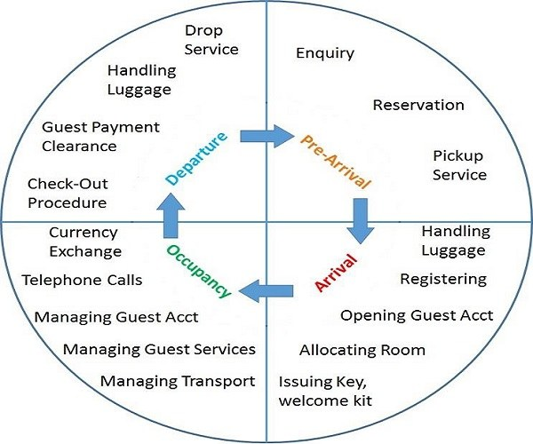
Figure 2. Guest Hotel Cycle
Pre-Arrival: The pre-arrival phase starts as soon as a visitor makes their reservation. It's a waiting period during which the hotel starts to customise the visitor's stay and sets their expectations. Effectively handling bookings and questions at this point sets the tone for the visitor's next visit.(Kumar, 2018)
Arrival: The first time a guest is physically touched is upon arrival. The goal of this stage is to create a memorable first impression. Warmly greeting visitors, attending to their urgent needs, and creating a comfortable environment are the goals of the actions that take place.(Kumar, 2018)
Occupancy: During the occupancy stage, the front office personnel should coordinate guest services efficiently and accurately. Front office staff should prioritise addressing guest complaints to increase recurring business. To ensure customer satisfaction, complaint and suggestion cards are strategically placed around the hotel's public areas and revenue centres.
Additionally, the hotel must gather and analyse visitor comments on a daily basis. Positive feedback should be provided to guests promptly.(Olasiman, n.d.)
Departure: The last phase of the guest cycle, departure, is just as significant as the welcome. This is your final chance to make a good impression. Making sure that every guest's demands are satisfied and that their departure is as enjoyable as their arrival requires careful handling of the departure procedure.(Kumar, 2018)
2.4 Emerging Trends in front Office
In today’s world of technology guests are getting used to advanced facilities and so they are expecting the same with the hotel industry. Slowly and steadily, the hotel industry is getting aware of the fact that; “In order to take advantage and stand out in the competition, it is important to stay updated with the latest trends in the hospitality industry.(Team, 2018)
An article by (Peter Szende and Pooja Reddy, 2017) fragment of the past shows how people used different stacks of rack to store customer data in a manual way.
Evolution of technology has made it convenient for customers to accesses facilities of choice and also assist hotels to generate revenue through online sales. Examples of emerging trends we have; chatbot assistance, mobile app for easy access, digitized room keys for quick room access, self-check-in to minimize guest waiting time, social media for promotion and voice-activated virtual assistants for everything and anything.

2.5 Conclusion
One of the sectors with the quickest rate of growth is tourism. It is a significant global economic activity. It offers a framework for job creation, economic expansion, and tax revenue development. In the tourism sector, a specific location is created with hotel amenities to give guests somewhere to sleep for a set amount of time. The growth of the hotel sector is crucial to the overall socioeconomic development of the nation.(Manana, 2018)

The research has revealed that the operations conducted in the front office can be very varied. The role of the front office towards customer satisfaction is vital as it determines how the stay of the customer will be. The arrival of the customer to the departure will determine if the customer will come again or not. The study also shows the importance of embracing technological changes in the hotel industry to be able to keep up with the emerging trends that will enable to increase customer interaction with the hotel and revenue for the hotel.
Finally, hotels can create an efficient control system approach that outlines the following crucial elements regarding standards for guest welcome. They need to be clear, well-reasoned, well-coordinated, precise, punctual, reasonable, and acceptable.

CHAPTER 3: RESEARCH DESIGN AND METHODOLOGY

3.1 Introduction
This chapter describes how the research was carried out from preliminary pages to the end.
It outlines the research design used, location of the study, target population, sampling techniques and sample size, research instruments, data collection procedures, data analysis and logical and ethical consideration of the study as a whole.

3.2 Research Design
A research design is a structured plan that guides a study. It outlines the study's objectives, methods, and techniques to achieve them. It provides a framework for data gathering, measurement, and analysis. It is the plan, organisation, and method of investigation devised to obtain an answer to a research issue.(khanday, 2023)
Questionnaire administration is part of this design. It will entail obtaining data regarding people’s beliefs, attitudes, methods and ideas. The design incorporates both qualitative and quantitative research approaches. This design will make it easier for the researcher to present the findings, analyse them logically, draw conclusions and offer suggestions concerning the subject topic of the role of front office towards customer satisfaction.

3.3. Location of the study
The study will be conducted at Kwetu Curio Collection by Hilton Nairobi. This is because Nairobi being the capital city of Kenya is a major economic hub and among the many five-star hotels in the city Kwetu curio is one of them. Also, the researcher was able to observe the flow of guest in an out of the hotels and wanted to delve in the study of the customers satisfaction as they leave the hotel premises.

3.4 Target Population
The target population of this study is the five-star hotel industry in Kenya, with a focus of Kwetu Curio Collection by Hilton Nairobi. The hotel has approximately 80 staff members, administration, 20, food and beverage 29 and food production 31. The population will include the front office manager, section supervisor and a few staff members of the front office department, as they have first-hand information concerning the study.
Administration Staff
Management | 5
Human Resource | 5
Finance | 4
Front office | 6
TOTAL | 20
Front Office Staff
Manager | 1
Assistant Manger | 1
Supervisor | 1
Staff Members | 3
TOTAL | 6

3.5 Sampling Techniques and Sample Size
A systematic sampling procedure will be used for selecting the participants in this study. This technique shall be employed to ensure a fairly equal representation of the variables for the study. The sample size shall be 80.

3.6 Research Instruments
A questionnaire designed by the researcher shall be used in the study. The questionnaire shall have five sections: A, B, C, D and E:
• Section “A”, is on personal data of the respondents;
• Section “B”, is on the main role of the front office department;
• Section “C” is on guest satisfaction
• Section “D” is on the methodology and materials for guest satisfaction
• Section “E”, is on the possible strategies that could be adopted for improved guest satisfaction. The instrument was structured in the modified Likert fashion, on a 4 – point scale, ranging from “strongly agree” (SA), through “agree” (A), “disagree” (D) to “strongly disagree” (SD). Subjects were then instructed to respond to their degree of agreement with the statements contained in the instrument.

3.7 Data Collection Procedure
After the pilot testing and all necessary modifications, the questionnaires shall be administered directly to the chosen sample for the study.

3.8 Data Analysis
The data collected from the field shall be analysed. Statistically weighted mean shall be used in answering the research questions. The response options in the instrument shall be weighted as shown below:
Strongly Agree (SA) | Agree (A) | Disagree (D) | Strongly Disagree (SD)
4 POINTS | 3 POINTS | 2 POINTS | 1 POINT

The t-test is defined as testing hypothesis about the differences between means when the sample size is small (Nworgu 1991:161). It is therefore, the t-test statistical analysis that shall be employed in testing the five null hypotheses used in this study. Then, when the calculated t-value is greater than the critical value of t, the null hypothesis shall be rejected and the alternative, which is “significance”, shall be accepted.
But if the calculated t-value is less than the critical t-value, the null hypothesis shall be accepted and the alternative rejected. However, the null hypotheses shall be tested at 0.05 (5 %) level of significance. This means 5 chances of being in error out of every 100 cases. That is, the chances of error are very low.

Logistical and Ethical Considerations
Ethical issues in research must be addressed by the logistics of the research plan. Ethics and logistics are therefore highly interrelated. These issues include privacy; confidentiality; voluntariness;

3.9.1 Privacy
Privacy in research requires potential participants to have the right to control access to themselves and their information. Names and contact information shall be protected
- 3.9.2 Confidentiality
In research, participants are often asked to share personal opinions. Respect for personal information requires that confidentiality be maintained. Confidentiality in research refers to agreements between participants and researchers about how identifiable data will be managed and to whom it will be disclosed.
- 3.9.3 Voluntariness
The informed consent process requires disclosure of information to potential research participants, ascertainment that the information is understood and assurance of participants’ voluntaries.

REFERENCE
Augustine. (2024, January 26). Front Office Department Introduction, Operations And Functions. SetupMyHotel. https://setupmyhotel.com/hotel-staff-training/front-office-training/front-office-department-introduction-operations-and-functions/
Haenraets, B. (2024, July 6). Front Desk impact on Customer Satisfaction. https://www.viqal.com/blog/front-desk-impact-on-customer-satisfaction
Hai‐yan, K., & Baum, T. (2006). Skills and work in the hospitality sector. International Journal ofContemporaryHospitalityManagement,18(6),509–518. https://doi.org/10.1108/09596110610681548
khanday, S. (2023, February). THE RESEARCH DESIGN. ResearchGate. https://www.researchgate.net/publication/368257495_THE_RESEARCH_DESIGN
Kumar, P. (2018, February 9). 4 Key Stages of Guest Cycle in Hotel with Activities & Diagram—IHM Notes by hmhub. https://hmhub.in/2nd-sem-front-office-notes/guest-cycle/
kwetu nairobi curio collection by hilton photos—Google Search. (n.d.). Retrieved November 20,2024.
Manana, V. (2018, March). Hotel Guest Service Technology. ResearchGate. https://www.researchgate.net/publication/323641929_Hotel_Guest_Service_Technology
Nkwanyane Samkeliso. (2011). Hotel Front Office Guide: Roles, Responsibilities, and Guest Satisfaction.https://www.hospitalitycourses.co.za/blog/hotel-front-office-roles-responsibilitiesguide?srsltid=AfmBOooRIgmWbpCQLKudITVk_BzcBFv6vHsS36E0_s03SAlVSBkOndXw
Olasiman, C. (n.d.). FRONT OFFICE OPERATIONS I-Guest Cycle. Retrieved November 21, 2024,fromhttps://www.academia.edu/22966534/FRONT_OFFICE_OPERATIONS_I_Guest_Cycle
Peter Szende and Pooja Reddy. (2017, June). A Fragment of the Past: The System of Hotel Front Office Racks | Boston Hospitality Review. https://www.bu.edu/bhr/2017/06/12/a-fragment-of-the-past-the-system-of-hotel-front-office-racks/
Team, eZee E. (2018). 11 Latest Hotel Industry Trends to Focus On for your Hotel’s Growth. eZee Absolute. https://www.ezeeabsolute.com/blog/hotel-industry-trends/

Johnson, R. A. &Wichern, D. W. (2007). Applied multivariate statistical analysis (6th edition). Pearson Prentice Hall, Upper Saddle River.
Morgan, C. J. (2017). Use of proper statistical techniques for research studies with small samples. American Journal of Physiology-Lung Cellular and Molecular Physiology, 313(5), L873-L877.
Nworgu, B. G. (1991). Educational research: Basic issues and methodology. Wisdom Publishers Ltd.

APPENDICES

APPENDIX 1: BUDGET
ACTIVITY | COST
Transport Expense | 700
Printing | 200
Internet Services | 1000
Binding Expenses | 100
Overhead | 1500
TOTAL COST | 3500

APPENDIX 2: WORKPLAN
ACTIVITY | WK3 | WK4 | WK5 | WK6 | WK7 | WK8 | WK9 | WK10 | WK11 | WK12 | WK13
Formulation of Research Topic
Objectives
Chapter One
Chapter Two
Chapter 3
Appendices: Data collection tools, Budget, workplan
Submission

APPENDIX 3: QUESTIONNAIRE
A study of the role of front office department towards guest satisfaction in five-star hotels, a case study conducted at Kwetu Curio Collection by Hilton Nairobi in partial fulfilment of the requirement for the award of a Diploma in Culinary Arts, Boma International Hospitality College. Information provided herein by the respondents shall be confidential.
I would be grateful if you could spare a few minutes to complete this questionnaire to help us establish the role of front office department towards guest satisfaction.
- Name ………………………………………………………………...
- Position ……………………………………………………………...
- Contact ……………………………………………………………...
- Date……………………………………………………………………
 | Excellent | Satisfied | Neutral | Dissatisfied | Very dissatisfied
How do guests rate your hotel room booking system
How do guests rate your Hotel check in experience
How do you rate your responsiveness in dealing with guests’ queries
How do guests rate your hotel’s check out process
How reliable are your assurances to guests while handling delays in your hotel’s service deliveries
How do you rate the neatness, professional appearance of your front office staff and the attractiveness of your hotel lobby

Do you have any additional feedback or any other suggestions for improving your hotel’s front office role in guests’ satisfaction?
______________________________________________________________________________________________________________________________________________________

